

FACULTY OF TECHNOLOGY AND ENGINEERING
DEVANG PATEL INSTITUTE OF ADVANCE TECHNOLOGY AND RESEARCH
DEPARTMENT OF INFORMATION TECHNOLOGY

A.Y. 2026-27 [SEMESTER 3]

LAB MANUAL

CEUE203: Object Oriented Programming


Practical 12

Collections framework
Problem Statement:
1. Word frequency: count words with a HashMap and sort by frequency using a Comparator.
2. Unique visitors: count users with a HashSet and retain first-seen order with LinkedHashSet.
3. Leaderboard: sort scores by descending score and then by player name.

Solution:

Leaderboard.java
import java.util.Comparator;
import java.util.Map;
public class Leaderboard {
public static void main(String[] args) {
Map<String, Integer> scores = Map.of(
"Riya", 94, "Aman", 87, "Dev", 94, "Neha", 78);
scores.entrySet().stream()
.sorted(Map.Entry.<String, Integer>comparingByValue(Comparator.reverseOrder())
.thenComparing(Map.Entry.comparingByKey()))
.limit(3)
.forEach(entry -> System.out.println(entry.getKey() + ": " + entry.getValue()));
}
}

UniqueVisitors.java
import java.util.HashSet;
import java.util.LinkedHashSet;
import java.util.List;
import java.util.Set;
public class UniqueVisitors {
public static void main(String[] args) {
List<String> logins = List.of("riya", "aman", "riya", "dev", "neha", "aman");
Set<String> uniqueUsers = new HashSet<>(logins);
Set<String> firstSeenOrder = new LinkedHashSet<>(logins);
System.out.println("Unique visitors: " + uniqueUsers.size());
System.out.println("First three: " + firstSeenOrder.stream().limit(3).toList());
}
}

WordFrequency.java
import java.util.Comparator;
import java.util.HashMap;
import java.util.Map;
public class WordFrequency {
public static void main(String[] args) {
String paragraph = "Java makes code clear. Java makes programs useful.";
Map<String, Integer> counts = new HashMap<>();
for (String word : paragraph.toLowerCase().replaceAll("[^a-z ]", "").split("\\s+")) {
counts.merge(word, 1, Integer::sum);
}
counts.entrySet().stream()
.sorted(Map.Entry.<String, Integer>comparingByValue(Comparator.reverseOrder())
.thenComparing(Map.Entry.comparingByKey()))
.forEach(entry -> System.out.println(entry.getKey() + ": " + entry.getValue()));
}
}

MiniBank Project Work:

MiniBank progress ? Practical 12
Completed: AccountStore keeps accounts keyed by number in a ConcurrentHashMap, records history, and sorts by balance. Account also implements Comparable by account number.
Single project location: Java Programs\Minibank

Progressive source excerpts:

Minibank/src/main/java/minibank/repository/AccountStore.java
package minibank.repository;
import java.util.ArrayList;
import java.util.Comparator;
import java.util.List;
import java.util.concurrent.ConcurrentHashMap;
import minibank.model.Account;
public final class AccountStore {
private final ConcurrentHashMap<String, Account> accounts = new ConcurrentHashMap<>();
private final List<String> transactionHistory = new ArrayList<>();
public void add(Account account) {
Account previous = accounts.putIfAbsent(account.getAccountNumber(), account);
if (previous != null) throw new IllegalArgumentException("Account already exists.");
}
public Account get(String accountNumber) { return accounts.get(accountNumber); }
public ArrayList<Account> getAll() { return new ArrayList<>(accounts.values()); }
public ArrayList<Account> sortedByBalance() {
ArrayList<Account> sorted = getAll();
sorted.sort(Comparator.comparingLong(Account::getBalance).reversed()
.thenComparing(Account::getAccountNumber));
return sorted;
}
public synchronized void addHistory(String transaction) {
transactionHistory.add(transaction);
}
public synchronized List<String> getHistory() {
return List.copyOf(transactionHistory);
}
}

Minibank/src/main/java/minibank/model/Account.java ? natural account ordering
public final int compareTo(Account other) {
return accountNumber.compareTo(other.accountNumber);
}

Output Screenshot:
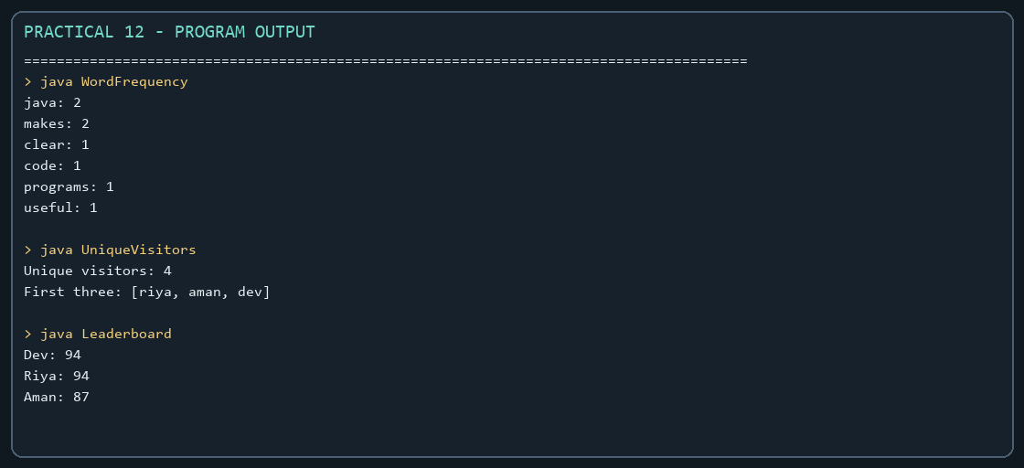
Captured from the compiled practical programs.

